1.Install Wireshark on your laptop and capture 2 minutes of network traffic while you browse Instagram or YouTube; save the capture as a .pcap file and note the top 3 protocols you see.
->Title: Wireshark Network Traffic Capture
Objective:
To capture 2 minutes of network traffic using Wireshark and identify the top 3 network protocols.
Procedure:
- Installed and opened Wireshark.
- Selected the Wi-Fi network interface.
- Started packet capture.
- Browsed YouTube for 2 minutes.
- Stopped the capture.
- Saved the capture as network_capture.pcapng.
- Opened Statistics → Protocol Hierarchy to view the captured protocols.
Top 3 Protocols Observed:
- QUIC IETF – Used by modern websites such as YouTube for fast and secure communication.
- UDP (User Datagram Protocol) – Used for fast data transmission with low latency.
- TCP (Transmission Control Protocol) – Ensures reliable and ordered delivery of data.
Conclusion:
Wireshark successfully captured the network traffic. The capture showed that QUIC, UDP, and TCP were the most commonly used protocols while browsing YouTube.
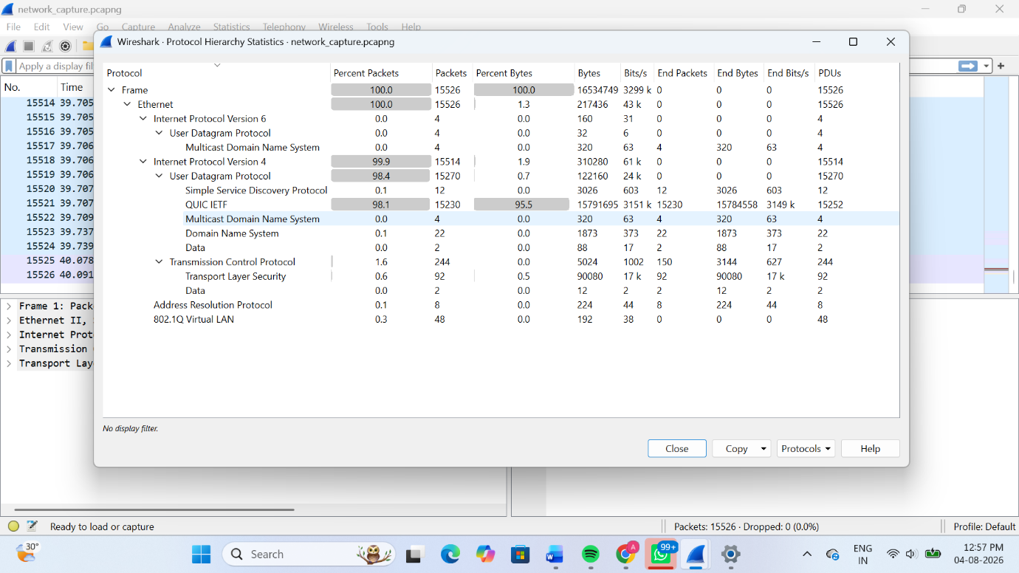
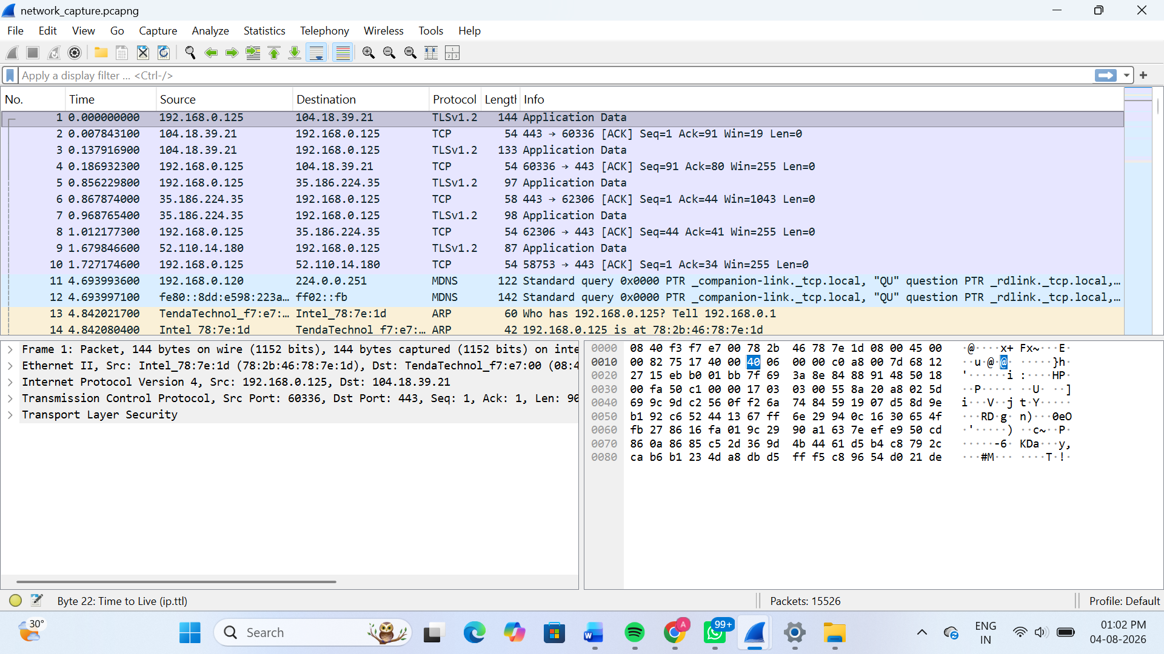
2.Use the 'ping' command in Command Prompt or Terminal to test connectivity to www.spotify.com and www.zomato.com; record the response times and identify which site responds faster.
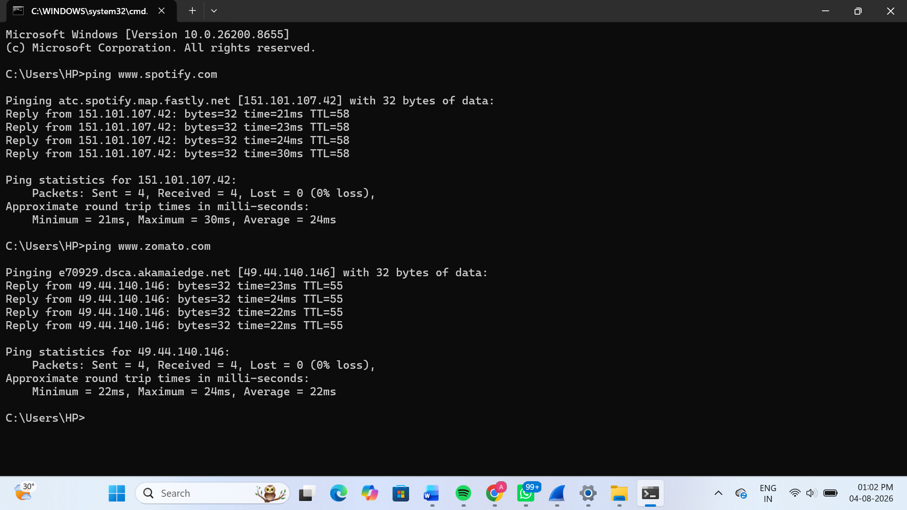
3.Open Task Manager (Windows) or Activity Monitor (Mac) and list all running processes related to Chrome, WhatsApp Desktop, or any browser-based app you use; note the process name and memory usage for each.
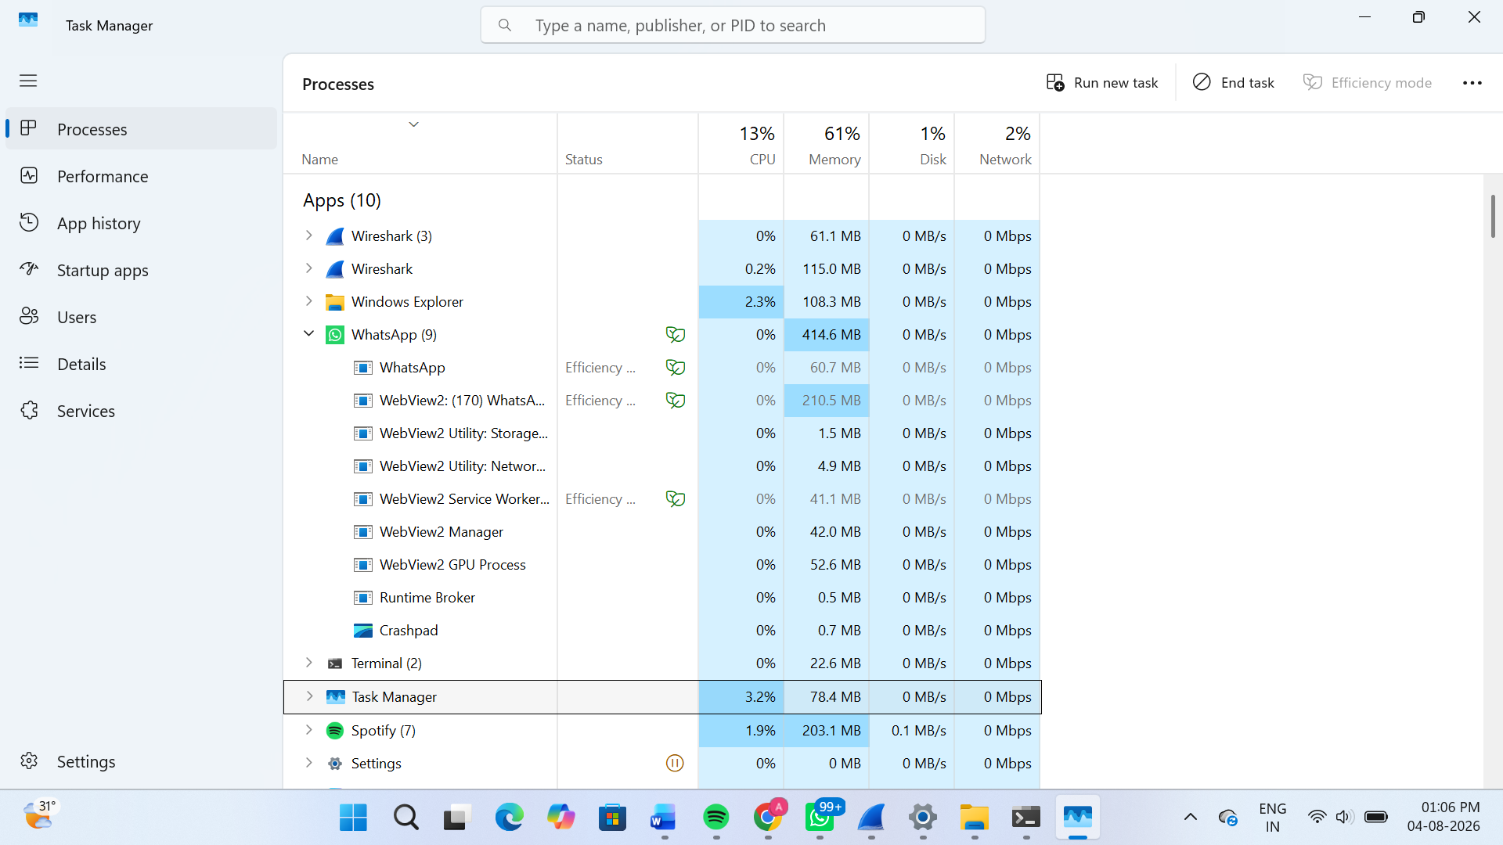
4.Download and run the free version of 'Angry IP Scanner' or 'Advanced IP Scanner' to scan your local WiFi network; list the IP and device name of at least 2 devices connected to your network.<br><br><em><strong>Hint:</strong> Make sure your firewall allows scanning, and only scan your own home/college network.</em>
5.Use ChatGPT or Bing AI to suggest 3 hardware tools (like cable tester, crimping tool, or multimeter) used in network troubleshooting; for each, write one line describing when you would use it.
Hardware Tool | When You Would Use It
Cable Tester | Used to check whether an Ethernet cable is wired correctly and detect cable faults.
Crimping Tool | Used to attach RJ-45 connectors to Ethernet cables while making or repairing network cables.
Digital Multimeter | Used to measure voltage, continuity, and electrical faults in network equipment and power supplies.

